

PSP [20ES104] COURSE PROJECT REPORT

On

“EduPortal”

Developed By:

H.T.NO STUDENT NAME
2203A51579 PARUCHURI UMESH CHANDRA

Under the Guidance of

Dr. Mohammed Ali Shaik, M.Tech.(Ph.D)
Assistant Professor

Submitted to
Department Computer Science and Artificial Intelligence SR University
Ananthasagar(V), Hasanparthy(M), Hanamkonda(Dist.) – 506371 www.sru.edu.in
June 2023
Department of Computer Science and Artificial Intelligence

CERTIFICATE

This is to certify that the PSP course project report entitled “EduPortal” is a record of bonafide work carried out by the student Paruchuri Umesh Chandra bearing roll number 2203A51579 of Computer Science and Artificial Intelligence department during the academic year 2022-23.

Supervisor

(Mohammed Ali Shaik)
INDEX

Sl. No Title Page No.
- Problem statement 1
- Module-wise description 3
- Knowledge required to develop the project 7
- Flowcharts 8
- Source code (.c file code followed by .h file code) 14
- Results 52

PROBLEM STATEMENT :
The objective of this project is to develop a Student Management System that efficiently manages student data by fetching, storing, and updating details in files. The system will offer a diverse range of functionalities, including login authentication, student data management, attendance tracking, fee payment management, internal assessment management, grievance resolution, password recovery mechanisms, and security features to safeguard student information Additionally, the system will facilitate administrative access to modify student details, provide an SGPA calculator for academic assessment, and offer a seamless account creation process for new users.
Provide the functionality for below mentioned:
- LogIn
- LogIn Authentication
- Profile
- Attendance
- Fee Payment
- Internals
- Grievance
- Change Password
- Reset Password

- Create New Account
- Check If Acoount Exists
- Set Password
- Set Security Question And Answer
- Input Student Details
- Save To Files
- SGPA Calculator
- Input Section & Branch
- Input Student’s Grades
- SGPA Calculation And Display
- Admin LogIn
- Authentication
- Update Student Details
- Attendance
- Internals
- Fee Details
- Change Student’s Password

MODULES:

In this application structure and variables are declared globally so that these variables and structure members can be accessed throughout the program at any function call. We can choose any function by using function calls which are declared in switch-case. In order to repeat the loop control statement is used with a condition. The user can select appropriate login option and continue as the program prompts for desired results.
In this application modules are used.

- User Authentication :

In this module The application provides login options through LogInOptions(). Users can enter their hall ticket number and password, which are then validated using CheckCredentials(). The existence of an account is checked using CheckIfAccountExists(). Upon successful login, user will be headed to home page where the user can select various options and view details

- Main Program Flow :
The program flow is controlled by SelectChoice() function, which prompts users to select an option or function. The main program is implemented in the main() function, which coordinates the execution of different modules based on user input.

- Create New Account :
This Module is responsible for creating a new user account. It prompts the user to enter their hall ticket number and password. Once the user provides these credentials, the function proceeds with validating and verifying them from file. CheckIfAccountExists(char HallTicketNo[]), This function checks if an account with the entered hall ticket number already exists. It takes the hall ticket number as a parameter and searches for a matching record in the system. User is prompted to set a security question and answer for the pupose of recovery. FillDetails(), After the account is successfully created, the FillDetails() function prompts the user to enter their personal details. The user is asked to provide information such as their name, contact details, and other relevant data. These details are necessary for maintaining student records and providing personalized services. SaveDetailsToFile(), Once the user has entered their details, the SaveDetailsToFile() function is called to store this information persistently. It saves the entered details to a file or database for future reference and retrieval. This ensures that the user's information is securely stored and can be accessed when needed.

- SGPA Calculation :
The Module is responsible for calculating the SGPA for a student. It takes into account the student's Section, Branch, and Grade points obtained to determine the overall performance. The final step in the SGPA calculation is to compute the SGPA by dividing the weighted average by the total credit points. The result represents the student's academic performance for a specific semester on a numerical scale.

- Admin LogIn :
The Admin Log In module provides a secure login mechanism for administrators to access privileged functions and perform administrative tasks such as changing student’s password and updating student details which include student’s attendance, internals and fee details.

- Account Recovery :
Users who encounter issues with their account or who forgot password can access the account recovery module. The application prompts users to select a security question which they previously selected while creating account using SelectSecurityQuestion(). The correctness of the security question and answer is verified from file using CheckSecurityQuestion() and CheckSecurityAnswer(). Upon sucessfull verification, Users can reset their password using ResetPassword().

KNOWLEDGE REQUIRED TO DEVELOP THIS APPLICATION

  - Control Statements (if, if-else, switch,goto)
  - Operators(Arthematic, Relational, Ternary, Unary, Logical, Assignment)
  - Strings (Strings Operations)
  - Functions (Any type of user defined functions)
  - Structure (structures and nested structures)
  - Files (Reading / Writing / Appending)

FLOWCHARTS :
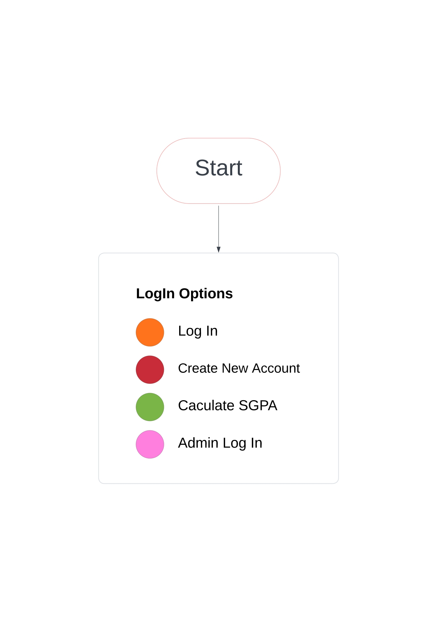
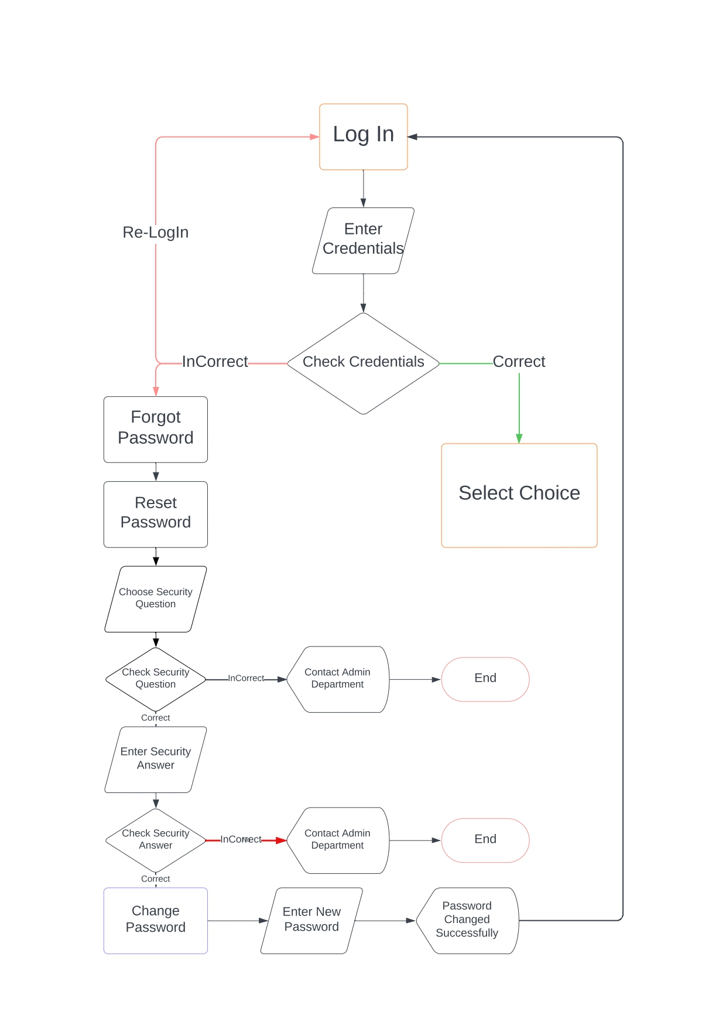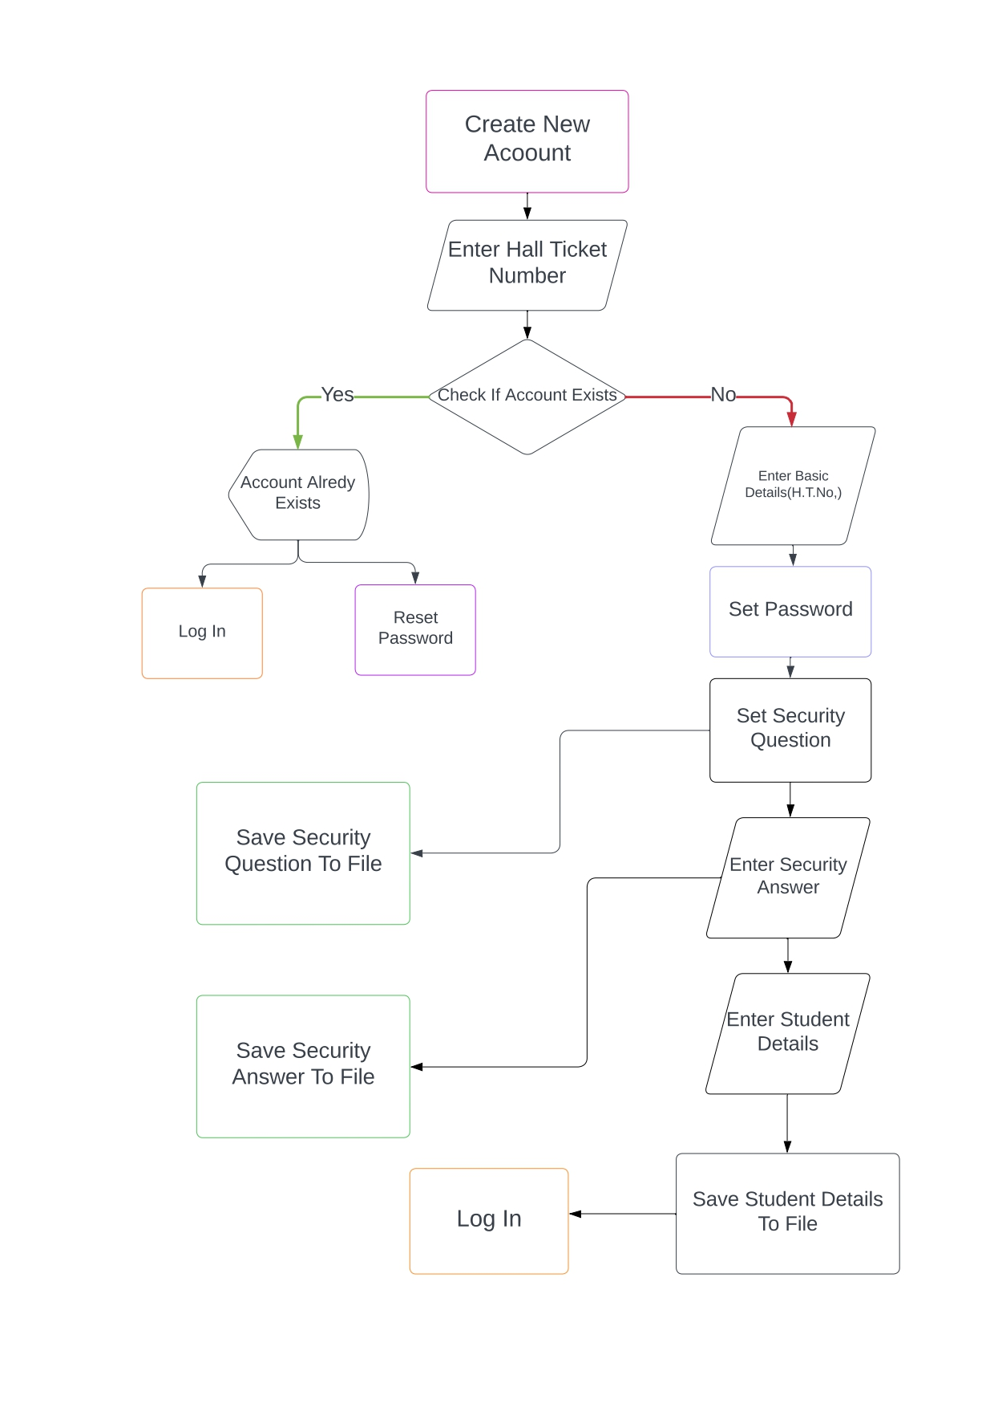
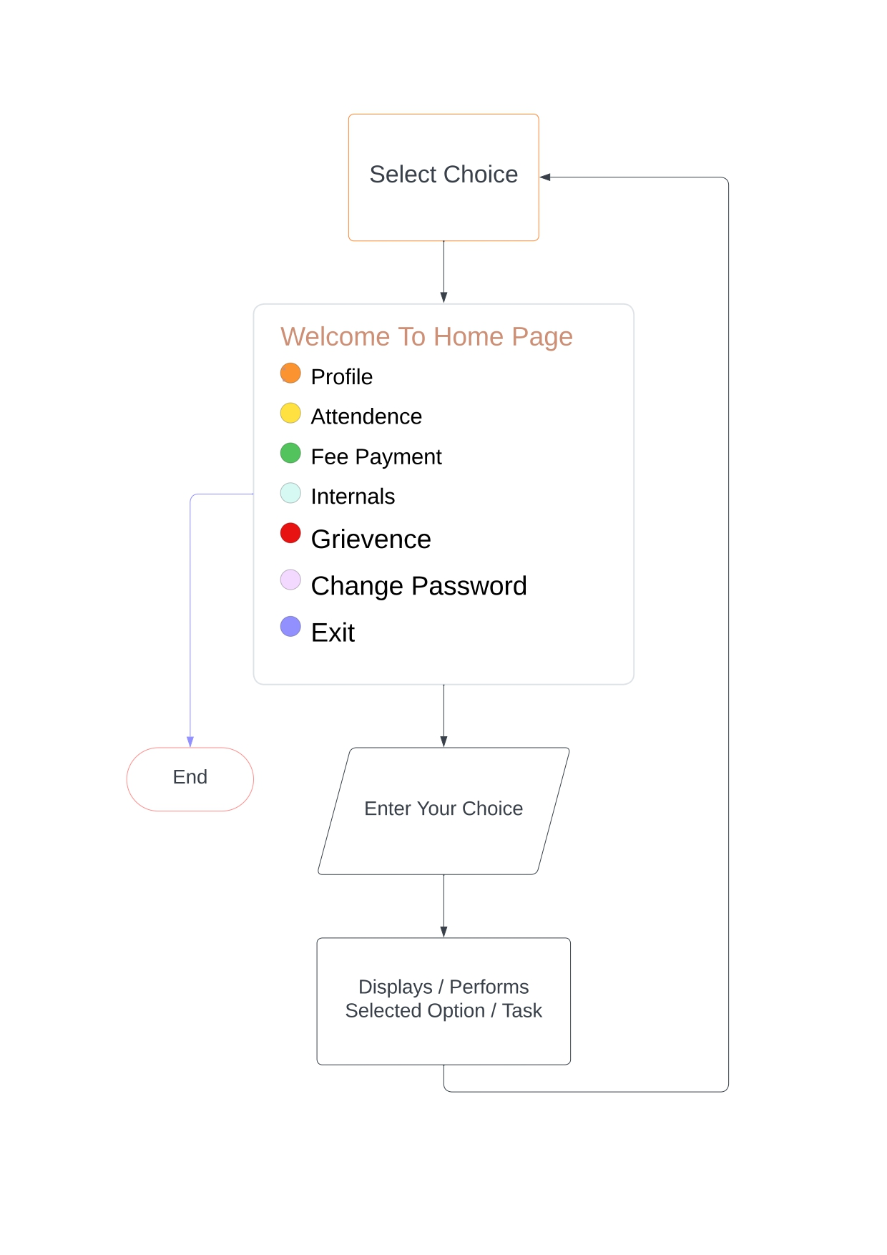
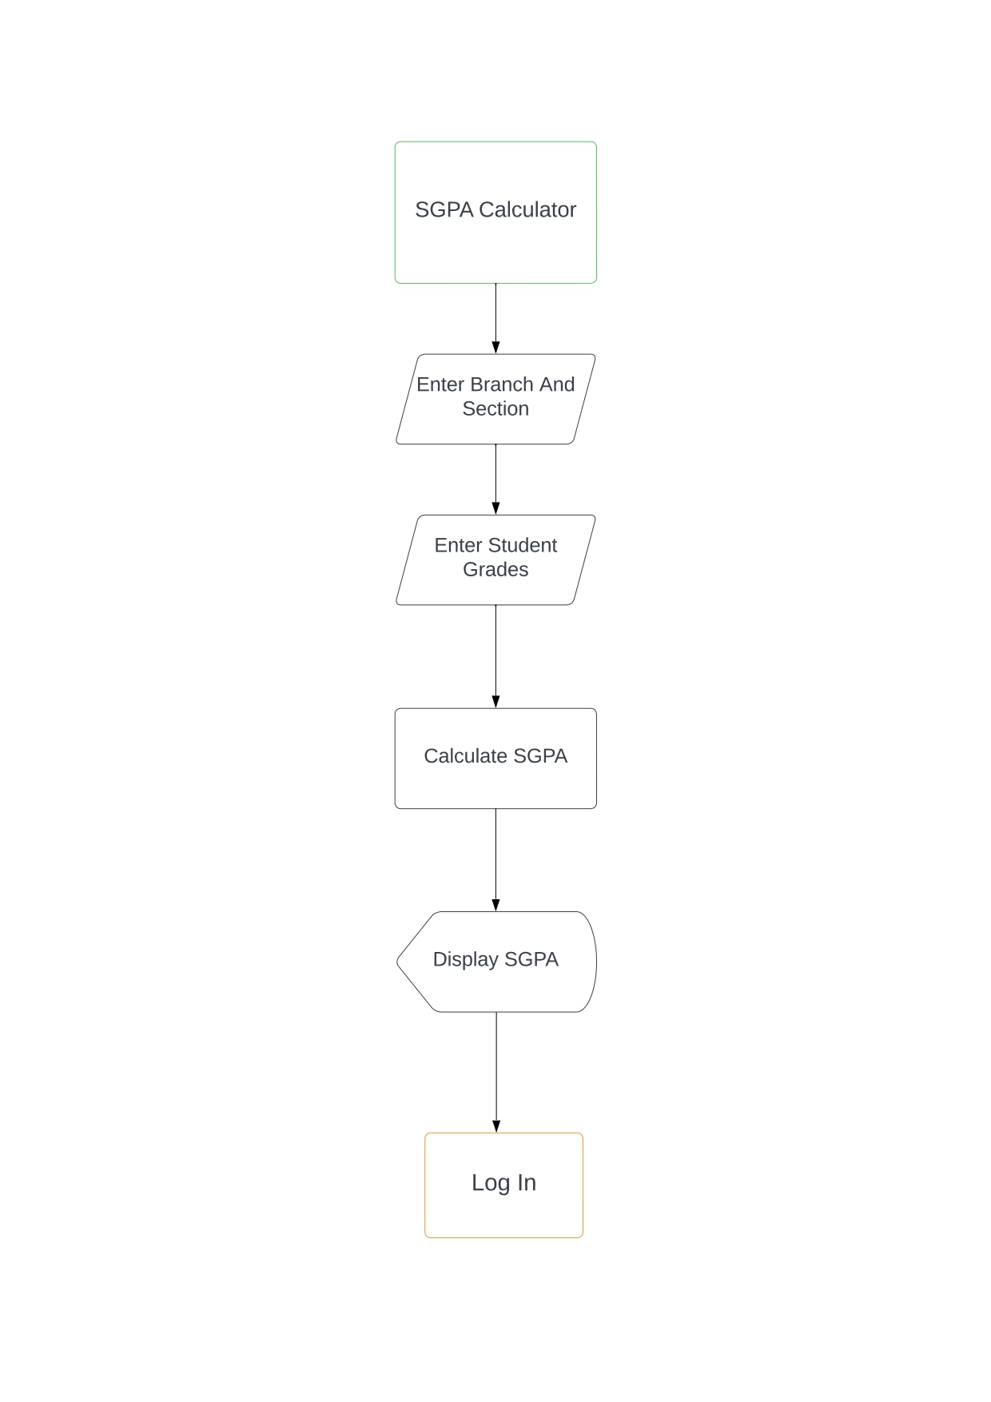
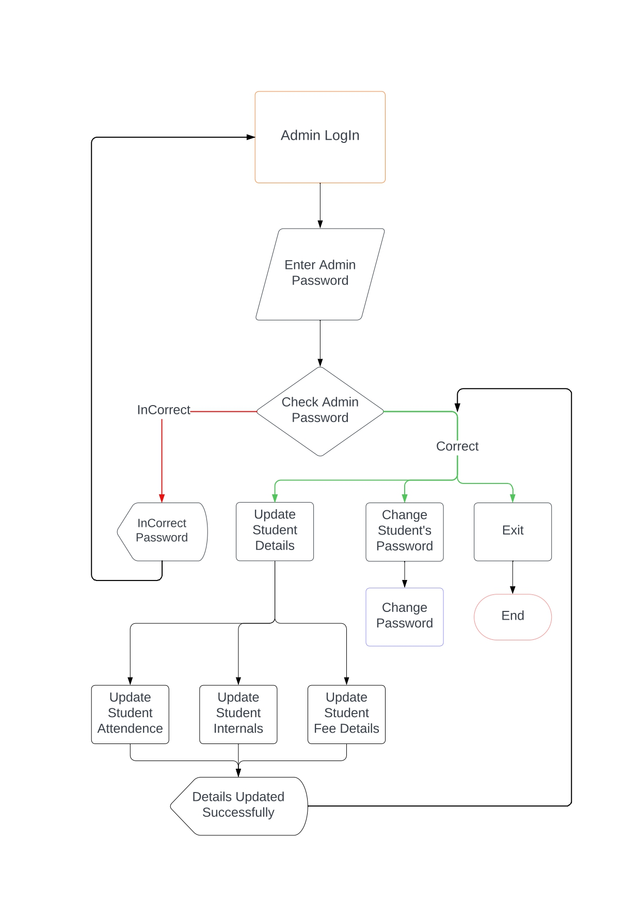
SOURCE CODE ( .c File ) :

/*
Developer Name : Paruchuri Umesh Chandra
University Name : SR University
University Email : 2203a51579@sru.edu.in
*/

#include<stdio.h>
#include<stdlib.h>
#include<string.h>
#include<math.h>

struct EduPortal{

// Personal Details :
char StudentName[25];
char FatherName[25];
char MotherName[25];
char MotherOcuupation[20];
char FatherOccupation[20];
char MotherNumber[11];
char FatherNumber[11];
char FamilyIncome[11];

// University Details :
char EmailAddress[22];
char PersonolMailAddress[30];
char HallTicketNo[11];
char Password[16];
char Passwordx[16];
char Passwordy[16];
char Branch[8];
char Degrree[8];
char AdmissionCategory[10];
char stay[10];

// SSC Details :
char THallticketNo[15];
char BoardOfStudy[10];
char TPassType[10];
char TMedium[10];
char YearOfPass[5];
char DOB[10];
char PhyscicallyHandicapped[5];
char SchoolName[25];
char TMarks[4];
char AdhaarNumber[12];

// Intermediate Details :
char IHallTicketNumber[15];
char IMarks[4];
char IPassType[10];
char IYearOfPass[5];
char Group[5];
char IMedium[10];
char CollegeName[25];

// CET Details :
char CETType[10];
char CETYear[5];
char CETHallTicketNo[15];
char CETRank[9];

// Medical Details :
char BloodGroup[3];
char IdentificationMarks1[50];
char IdentificationMarks2[50];
}stux;

// Global Declarations Of Variables :
char MailChecker[21];
char PasswordChecker[21];
int MailIndex = 0;
int PasswordIndex = 0;
int WrongPasswordCount = 0;
int Retry = 0;

// Security Questions :
char SQ1[] = "What Is Your GirlFriend's First Name ?";
char SQ2[] = "What Is Your Pet's Name ?";
char SQ3[] = "What Is Your Birth Place ?";
char SQ4[] = "Where Did You Propose Your Girlfriend ?";
char SQ5[] = "What Is Your Lucky Number ?";

void AdminLogIn(){
char AdminPassword[] = "1413914";
char AdminPasswordChecker[10];
Admin : printf("Enter Admin Password :");
gets(AdminPasswordChecker);
fflush(stdin);
if (strcmp(AdminPasswordChecker,AdminPassword) == 0 ){
int Choice;
AdminControls : printf("Press \n1 To Update Student Details \n2 To Change Student's Password\n3 To Exit\n");
printf("\nPlease Enter Your Choice : ");
scanf("%d",&Choice);
fflush(stdin);
printf("Enter Student's Hall Ticket Number : ");
gets(stux.HallTicketNo);
fflush(stdin);
if(Choice == 1){
UpdateStudentdetails();
goto AdminControls;
}
else if (Choice == 2){
ChangePassword();
goto AdminControls;
}
else if (Choice == 3){
goto End;
}
else{
printf("\n\tYou Have Entered Incorrecct Choice \nPlease Enter Correcly\n");
goto AdminControls;
}
}
else{
printf("Incorrect Admin Password ! Please Try Again");
goto Admin;
}
End : return;
}

void UpdateStudentAttendence(){
printf("\n\n");
char StudentProfileFileName[25];
char Attendence[15] = "Attendence.txt";
strcat(strcpy(StudentProfileFileName,stux.HallTicketNo),Attendence);
FILE *UpdateFilePointer = fopen(StudentProfileFileName,"w+");
if (UpdateFilePointer == NULL) {
printf("\n\tProfile Can't Be Opened \n");
printf("\n\tPlease Contact Administration Department InCase Of New Account\n");
fclose(UpdateFilePointer);
UpdateStudentdetails();
}
else{
float Attendence;
printf("Enter Attendence In Engineering Mathematics : ");
scanf("%f",&Attendence);
fprintf(UpdateFilePointer,"Engineering Mathematics %.2f %%\n",Attendence);
printf("Enter Attendence In Applied Physics : ");
scanf("%f",&Attendence);
fprintf(UpdateFilePointer,"Applied Physics %.2f %%\n",Attendence);
printf("Enter Attendence In Problem Solving In Programming : ");
scanf("%f",&Attendence);
fprintf(UpdateFilePointer,"Problem Solving In Programming %.2f %%\n",Attendence);
printf("Enter Attendence In English Language Enrichment : ");
scanf("%f",&Attendence);
fprintf(UpdateFilePointer,"English Language Enrichment %.2f %%\n",Attendence);
printf("Enter Attendence In Problem Solving In Programming Lab : ");
scanf("%f",&Attendence);
fprintf(UpdateFilePointer,"Problem Solving In Programming Lab %.2f %%\n",Attendence);
printf("Enter Attendence In Product Design Studio : ");
scanf("%f",&Attendence);
fprintf(UpdateFilePointer,"Product Design Studio %.2f %%\n",Attendence);
printf("Enter Attendence In Advanced Programming Tools And Techniques Lab : ");
scanf("%f",&Attendence);
fprintf(UpdateFilePointer,"Advanced Programming Tools And Techniques %.2f %%\n",Attendence);
printf("Enter Attendence In Engineering Physics Lab : ");
scanf("%f",&Attendence);
fprintf(UpdateFilePointer,"Engineering Physics Lab %.2f %%\n",Attendence);
printf("\n\tDetails Updated Sucessfully\n");
}
fclose(UpdateFilePointer);
}

void UpdateStudentFeePayment(){
char StudentFeePaymentFileName[25];
char FeePayment[15] = "FeePayment.txt";
char ch;
strcat(strcpy(StudentFeePaymentFileName,stux.HallTicketNo),FeePayment);
printf("\n\n");
FILE *UpdateFeePaymentPointer = fopen(StudentFeePaymentFileName,"w+");
if (UpdateFeePaymentPointer == NULL) {
printf("\n\tFeePayment Can't Be Opened \n");
printf("\n\tPlease Contact Administration Department InCase Of New Account\n");
fclose(UpdateFeePaymentPointer);
UpdateStudentdetails();
return;
}
else{
float SemFee,PaidFee;
float Zero = 0.000000;
printf("Enter Semester Fee : ");
scanf("%f",&SemFee);
fprintf(UpdateFeePaymentPointer,"Semester Fee : %.2f Rs\n",SemFee);
printf("Enter Amount Paid : ");
scanf("%f",&PaidFee);
fprintf(UpdateFeePaymentPointer,"Amount Paid : %.2f Rs\n",PaidFee);
fprintf(UpdateFeePaymentPointer,"Due Fee : %.2f Rs\n",(SemFee-PaidFee) >= 0 ? SemFee-PaidFee : Zero );
printf("\n\tDetails Updated Sucessfully\n");
}
fclose(UpdateFeePaymentPointer);
}

void UpdateStudentInternals(){
char StudentInternalsFileName[25];
char Internals[15] = "Internals.txt";
strcat(strcpy(StudentInternalsFileName,stux.HallTicketNo),Internals);
printf("\n\n");
FILE *UpdateInternalsPointer = fopen(StudentInternalsFileName,"w+");
if (UpdateInternalsPointer == NULL) {
printf("\n\tInternals Can't Be Opened \n");
printf("\n\tPlease Contact Administration Department InCase Of New Account\n");
fclose(UpdateInternalsPointer);
UpdateStudentdetails();
}
else{
float int1,int2;
printf("Enter Mid 1 Engineering Mathematics Marks : ");
scanf("%f",&int1);
printf("Enter Mid 2 Engineering Mathematics Marks : ");
scanf("%f",&int2);
fprintf(UpdateInternalsPointer,"Engineering Mathematics %.2f\n", (int1>int2) ? ((int1*0.75+int2*0.25)) : ((int2*0.75+int1*0.25)));
printf("Enter Mid 1 Applied Physics Marks : ");
scanf("%f",&int1);
printf("Enter Mid 2 Applied Physics Marks : ");
scanf("%f",&int2);
fprintf(UpdateInternalsPointer,"Applied Physics %.2f\n", (int1>int2) ? ((int1*0.75+int2*0.25)) : ((int2*0.75+int1*0.25)));
printf("Enter Mid 1 Problem Solving In Programming Marks : ");
scanf("%f",&int1);
printf("Enter Mid 2 Problem Solving In Programming Marks : ");
scanf("%f",&int2);
fprintf(UpdateInternalsPointer,"Problem Solving In Programming %.2f\n", (int1>int2) ? ((int1*0.75+int2*0.25)) : ((int2*0.75+int1*0.25)));
printf("Enter Mid 1 English Language Enrichment Marks : ");
scanf("%f",&int1);
printf("Enter Mid 2 English Language Enrichment : ");
scanf("%f",&int2);
fprintf(UpdateInternalsPointer,"English Language Enrichment %.2f\n", (int1>int2) ? ((int1*0.75+int2*0.25)) : ((int2*0.75+int1*0.25)));
printf("Enter Mid 1 Problem Solving In Programming Lab Marks : ");
scanf("%f",&int1);
printf("Enter Mid 2 Problem Solving In Programming Lab Marks : ");
scanf("%f",&int2);
fprintf(UpdateInternalsPointer,"Problem Solving In Programming Lab %.2f\n", (int1>int2) ? ((int1*0.75+int2*0.25)) : ((int2*0.75+int1*0.25)));
printf("Enter Mid 1 Product Design Studio Marks : ");
scanf("%f",&int1);
printf("Enter Mid 2 Product Design Studio Marks : ");
scanf("%f",&int2);
fprintf(UpdateInternalsPointer,"Product Design Studio %.2f\n", (int1>int2) ? ((int1*0.75+int2*0.25)) : ((int2*0.75+int1*0.25)));
printf("Enter Mid 1 Advanced Programming Tools And Techniques Marks : ");
scanf("%f",&int1);
printf("Enter Mid 2 Advanced Programming Tools And Techniques Marks : ");
scanf("%f",&int2);
fprintf(UpdateInternalsPointer,"Advanced Programming Tools And Techniques %.2f\n", (int1>int2) ? ((int1*0.75+int2*0.25)) : ((int2*0.75+int1*0.25)));
printf("Enter Mid 1 Engineering Physics Lab Marks : ");
scanf("%f",&int1);
printf("Enter Mid 2 Engineering Physics Lab Marks : ");
scanf("%f",&int2);
fprintf(UpdateInternalsPointer,"Engineering Physics Lab %.2f\n", (int1>int2) ? ((int1*0.75+int2*0.25)) : ((int2*0.75+int1*0.25)));
printf("\n\tDetails Updated Sucessfully !\n");
}
fclose(UpdateInternalsPointer);
}

void UpdateStudentdetails(){
int Choice;
printf("\nWhat Do You Want To Update \n 1.Attendence \n 2.FeePayment \n 3.Internals\n");
UpdateOptions : printf("\nPlease Enter Your Choice : ");
scanf("%d",&Choice);
fflush(stdin);
switch (Choice)
{
case 1:
UpdateStudentAttendence();
break;
case 2:
UpdateStudentFeePayment();
break;
case 3:
UpdateStudentInternals();
break;
default:
printf("\n\tYou Have Selected Wrong Choice Please Enter Correcly !\n");
goto UpdateOptions;
break;
}
}

int SubstringCheck(char* s1, char* s2){
int M = strlen(s1);
int N = strlen(s2);
for (int i = 0; i <= N - M; i++) {
int j;
for (j = 0; j < M; j++)
if (s2[i + j] != s1[j])
break;
if (j == M)
return 1;
}
return 0;
}

void CalcSgpa(){
// Credits :
int CDE_C = 4;
int ELE_C = 2;
int EP_C = 3;
int SSD_C = 3;
int PDS_C = 3;
int EPL_C = 1;
int BEEE_C = 3;
int IP_C = 2;
int IPL_C = 1;
int PTT_C = 2;
int EC_C = 3;
int GDM_C = 2;
int ECL_C = 1;
float GPA = 0;
char Branch[5];
char Section[4];
int CDE_GP, EP_GP, IP_GP, ELE_GP, EC_GP, BEEE_GP;
int PDS_GP, IPL_GP, PTT_GP, EPL_GP, GDM_GP, ECL_GP, SSD_GP;
printf("\n\t\t\t-------------------------------------SGPA Calculator-------------------------------------\n");
printf("Existing Branches : \n CSE \n ECE \n EEE \n Mechanical \n Civil \n\n Enter Your Branch (Use Upper Case) : ");
gets(Branch);
fflush(stdin);
printf("\nExisting Sections :\n\n A1 B1 C1 D1 E1 F1 G1 H1 I1 J1 K1 \n A2 B2 C2 D2 E2 F2 G2 H2 I2 J2 K2 \n\n Enter Your Section : ");
gets(Section);
fflush(stdin);
printf("\n\n");
if (strcmp(Branch,"CSE") == 0 && SubstringCheck("1",Section)){
printf("\nTheory:\n");
printf("Enter Grade in C&DE: ");
scanf("%d", &CDE_GP);
printf("Enter Grade in EP: ");
scanf("%d", &EP_GP);
printf("Enter Grade in IP: ");
scanf("%d", &IP_GP);
printf("Enter Grade in ELE: ");
scanf("%d", &ELE_GP);
printf("\nLabs:\n");
printf("Enter Grade in PDS: ");
scanf("%d", &PDS_GP);
printf("Enter Grade in IPL: ");
scanf("%d", &IPL_GP);
printf("Enter Grade in PTT: ");
scanf("%d", &PTT_GP);
printf("Enter Grade in EPL: ");
scanf("%d", &EPL_GP);
GPA = (float)(CDE_C * CDE_GP + EP_C * EP_GP + IP_C * IP_GP + ELE_C * ELE_GP + PDS_C * PDS_GP + EPL_C * EPL_GP + IPL_C * IPL_GP + PTT_C * PTT_GP) / (CDE_C + EP_C + IP_C + ELE_C + PDS_C + EPL_C + IPL_C + PTT_C);
}

else if ((strcmp(Branch,"ECE") == 0 || strcmp(Branch,"EEE") == 0) && SubstringCheck("1",Section)){
printf("\nTheory:\n");
printf("Enter Grade in C&DE: ");
scanf("%d", &CDE_GP);
printf("Enter Grade in EP: ");
scanf("%d", &EP_GP);
printf("Enter Grade in IP: ");
scanf("%d", &IP_GP);
printf("Enter Grade in ELE: ");
scanf("%d", &ELE_GP);
printf("\nLabs:\n");
printf("Enter Grade in PDS: ");
scanf("%d", &PDS_GP);
printf("Enter Grade in IPL: ");
scanf("%d", &IPL_GP);
printf("Enter Grade in GDM: ");
scanf("%d", &GDM_GP);
printf("Enter Grade in EPL: ");
scanf("%d", &EPL_GP);
GPA = (float)((CDE_C*CDE_GP)+(EP_C*EP_GP)+(IP_C*IP_GP)+(ELE_C*ELE_GP)+(PDS_C*PDS_GP)+(EPL_C*EPL_GP)+(IPL_C*IPL_GP)+(GDM_C*GDM_GP))/((CDE_C)+(EP_C)+(IP_C)+(ELE_C)+(PDS_C)+(EPL_C)+(IPL_C)+(GDM_C));
}

else if ((strcmp("Mechanical",Branch) == 0 || strcmp("Civil",Branch) == 0) && SubstringCheck("1",Section)){
printf("\nTheory:\n");
printf("Enter Grade in C&DE: ");
scanf("%d", &CDE_GP);
printf("Enter Grade in EP: ");
scanf("%d", &EP_GP);
printf("Enter Grade In EC : ");
scanf("%d", &EC_GP);
printf("\nLabs:\n");
printf("Enter Grade in PDS: ");
scanf("%d", &PDS_GP);
printf("Enter Grade in GDM: ");
scanf("%d", &GDM_GP);
printf("Enter Grade In ECL : ");
scanf("%d", &ECL_GP);
GPA = (float)((CDE_C*CDE_GP)+(EP_C*EP_GP)+(EC_C*EC_GP)+(PDS_C*PDS_GP)+(ECL_C*ECL_GP)+(GDM_C*GDM_GP))/((CDE_C)+(EP_C)+(EC_C)+(PDS_C)+(ECL_C)+(GDM_C));
}

else if (strcmp(Branch,"CSE") == 0 && SubstringCheck("2",Section)){
printf("\nTheory:\n");
printf("Enter Grade in C&DE: ");
scanf("%d", &CDE_GP);
printf("Enter Grade in EP: ");
scanf("%d", &EP_GP);
printf("Enter Grade in IP: ");
scanf("%d", &IP_GP);
printf("Enter Grade in BEEE: ");
scanf("%d", &BEEE_GP);
printf("\nLabs:\n");
printf("Enter Grade in SSD: ");
scanf("%d", &SSD_GP);
printf("Enter Grade in IPL: ");
scanf("%d", &IPL_GP);
printf("Enter Grade in PTT: ");
scanf("%d", &PTT_GP);
printf("Enter Grade in EPL: ");
scanf("%d", &EPL_GP);
GPA = (float)((CDE_C*CDE_GP)+(EP_C*EP_GP)+(IP_C*IP_GP)+(BEEE_C*BEEE_GP)+(SSD_C*SSD_GP)+(EPL_C*EPL_GP)+(IPL_C*IPL_GP)+(PTT_C*PTT_GP))/((CDE_C)+(EP_C)+(IP_C)+(BEEE_C)+(SSD_C)+(EPL_C)+(IPL_C)+(PTT_C));
}

else if ((strcmp(Branch,"ECE") == 0 || strcmp(Branch,"EEE") == 0) && SubstringCheck("2",Section)){
printf("\nTheory:\n");
printf("Enter Grade in C&DE: ");
scanf("%d", &CDE_GP);
printf("Enter Grade in EP: ");
scanf("%d", &EP_GP);
printf("Enter Grade in IP: ");
scanf("%d", &IP_GP);
printf("Enter Grade in BEEE: ");
scanf("%d", &BEEE_GP);
printf("\nLabs:\n");
printf("Enter Grade in SSD: ");
scanf("%d", &SSD_GP);
printf("Enter Grade in IPL: ");
scanf("%d", &IPL_GP);
printf("Enter Grade in EPL: ");
scanf("%d", &EPL_GP);
printf("Enter Grade in GDM: ");
scanf("%d", &GDM_GP);
GPA = (float)((CDE_C*CDE_GP)+(EP_C*EP_GP)+(IP_C*IP_GP)+(BEEE_C*BEEE_GP)+(SSD_C*SSD_GP)+(EPL_C*EPL_GP)+(IPL_C*IPL_GP)+(GDM_C*GDM_GP))/((CDE_C)+(EP_C)+(IP_C)+(BEEE_C)+(SSD_C)+(EPL_C)+(IPL_C)+(GDM_C));
}

else if ((strcmp("Mechanical",Branch) == 0 || strcmp("Civil",Branch) == 0) && SubstringCheck("2",Section)){
printf("\nTheory:\n");
printf("Enter Grade in C&DE: ");
scanf("%d", &CDE_GP);
printf("Enter Grade in EP: ");
scanf("%d", &EP_GP);
printf("Enter Grade In EC : ");
scanf("%d", &EC_GP);
printf("\nLabs:\n");
printf("Enter Grade in SSD: ");
scanf("%d", &SSD_GP);
printf("Enter Grade in EPL: ");
scanf("%d", &EPL_GP);
printf("Enter Grade in GDM: ");
scanf("%d", &GDM_GP);
printf("Enter Grade In ECL : ");
scanf("%d", &ECL_GP);
GPA = (float)((CDE_C*CDE_GP)+(EP_C*EP_GP)+(EC_C*EC_GP)+(SSD_C*SSD_GP)+(EPL_C*EPL_GP)+(ECL_C*ECL_GP)+(GDM_C*GDM_GP))/((CDE_C)+(EP_C)+(EC_C)+(SSD_C)+(EPL_C)+(ECL_C)+(GDM_C));
}

else{
printf("\n\tInvalid Section Name Or Branch Name Please Enter It Correclty\n\n\n");
LogInOptions();
}

if(GPA>10){
printf("\n\tYou Have Entered Invalid Inputs For Grade Points Please Enter Correctly\n\n\n");
LogInOptions();
}
else{
printf("\n\tYour SGPA Is : %.3f\n",GPA) ;
printf("\n\t\t\t\t\t\t\tThank You !\n\n\n");
LogInOptions();
}
}

void LogInOptions(){
int x;
printf("Press \n1 To Log In To Existing Account\n2 To Create New Account\n3 To Calculate SGPA\n4 For Admin Login\n");
printf("\nEnter Your Choice : ");
scanf("%d",&x);
fflush(stdin);
if ( x == 1 )
LogIn();
else if ( x == 2 )
CreateNewAcccount();
else if ( x == 3 )
CalcSgpa();
else if ( x == 4 )
AdminLogIn();
else{
printf("\n\tYou Have Choosen Invalid Option\n\nPlease Select Again :\n");
LogInOptions();
}
}

int CheckCredentials( char HallTicketNo[], char Password[]) {
char HallTicketChecker[22];
char PasswordChecker[15];
FILE* CheckCredentialsFilePointer;
CheckCredentialsFilePointer = fopen("Emails_Passwords.txt", "r");
if (CheckCredentialsFilePointer == NULL) {
printf("\n\tError Checking Credentials.\n");
return 0;
}
while (fscanf(CheckCredentialsFilePointer, "%s %s", HallTicketChecker, PasswordChecker) != EOF) {
if (strcmp(HallTicketNo, HallTicketChecker) == 0 && strcmp(Password, PasswordChecker) == 0) {
fclose(CheckCredentialsFilePointer);
return 1;
}
}
fclose(CheckCredentialsFilePointer);
return 0;
}

int CheckIfAccountExists(char HallTicketNo[]){
char HallTicketChecker[22];
FILE* CheckAccountExistsPointer;
CheckAccountExistsPointer = fopen("Emails_Passwords.txt", "r");
if (CheckAccountExistsPointer == NULL) {
printf("\n\tError Checking If Account Exists.\n");
return 0;
}
while (fscanf(CheckAccountExistsPointer, "%s", HallTicketChecker) != EOF) {
if (strcmp(HallTicketNo, HallTicketChecker) == 0 ) {
fclose(CheckAccountExistsPointer);
return 1;
}
}
fclose(CheckAccountExistsPointer);
return 0;
}

void LogIn(){
printf("\nEnter Your University Hall Ticket Number : ");
gets(stux.HallTicketNo);
fflush(stdin);
printf("Enter Your Password : ");
gets(stux.Password);
fflush(stdin);
if (CheckCredentials(stux.HallTicketNo,stux.Password)){
printf("\n\n\tLog In Sucessfull\n\n");
SelectChoice();
}
else{
if(WrongPasswordCount >= 2){
int CH;
printf("\nPress \n1.If You Forgot Your Password\n2.To Log In\n");
EnteraChoice :printf("\nEnter Your Choice : ");
scanf("%d",&CH);
printf("\n");
if(CH == 1)
ResetPassword(stux.HallTicketNo);
else if (CH == 2)
LogIn();
else {
printf("\n\tYou Have Entered Wrong Choice ! Pleasse Re-Enter It Correctly !\n");
goto EnteraChoice;
}
}
else{
printf("\n\tIncorrect University Hall Ticket Number Or Password\n");
printf("\n\tTry Logging In Again\n\n");
WrongPasswordCount++;
LogIn();
}
}
}

void CreateNewAcccount(){
int Ch;
FILE *CreateNewAcc;
FILE *AddSecurityQuestionsPointer;
FILE *AddSecurityAnswersPointer;
CreateNewAcc = fopen("Emails_Passwords.txt","a+");
AddSecurityQuestionsPointer = fopen("Security_Questions.txt","a+");
AddSecurityAnswersPointer = fopen("Security_Answers.txt","a+");
printf("\nEnter Your University Hall Ticket Number : ");
gets(stux.HallTicketNo);
fflush(stdin);
if (CheckIfAccountExists(stux.HallTicketNo)){
printf("\n\tAn Account Exists With Hall Ticket Number %s !\n",stux.HallTicketNo);
ExistsChoices : printf("Press \n 1 To Log In\n 2 If You Dont Remember Your Password\n 3 To Start Again\n");
printf("\nSelect Your Choice : ");
scanf("%d",&Ch);
fflush(stdin);
if (Ch == 1){
LogIn();
}
else if (Ch == 2){
ResetPassword(stux.HallTicketNo);
}
else if (Ch == 3){
main();
}
else{
printf("\n\tYour Have Entered Wrong Choice Please Enter It Again !\n");
goto ExistsChoices;
}
}
else{
fprintf(CreateNewAcc,"\n%s ",stux.HallTicketNo);
ReEnterPassword : printf("Enter Password : ");
gets(stux.Passwordx);
fflush(stdin);
printf("Re-Enter Password : ");
gets(stux.Passwordy);
fflush(stdin);
if(strcmp(stux.Passwordx,stux.Passwordy) == 0){
strcpy(stux.Password,stux.Passwordx);
fprintf(CreateNewAcc,"%s",stux.Password);
}
else{
printf("\n\tPasswords Donot Match !!\n");
goto ReEnterPassword;
}
fclose(CreateNewAcc);
printf("\n\nSelect A Security Question : \n");
int SQNumber = SelectSecurityQuestion();
char SQChoice[7];
char SecurityAns[25];
switch (SQNumber){
case 1:
strcpy(SQChoice,"One");
break;
case 2:
strcpy(SQChoice,"Two");
break;
case 3:
strcpy(SQChoice,"Three");
break;
case 4:
strcpy(SQChoice,"Four");
break;
case 5:
strcpy(SQChoice,"Five");
break;
}
printf("\nEnter Answer To The Security Question Selected (In One Word) : ");
gets(SecurityAns);
fflush(stdin);
fprintf(AddSecurityQuestionsPointer, "\n%s %s", stux.HallTicketNo, SQChoice);
fprintf(AddSecurityAnswersPointer, "\n%s %s", stux.HallTicketNo, SecurityAns);
fclose(AddSecurityAnswersPointer);
fclose(AddSecurityQuestionsPointer);
FillDetails();
}
}

void FillDetails(){
printf(" \n\t\tNote : Details Once Given Cannot Be Changed By Student.\n\n");
printf(" \t\t Details Can Only Be Changed By Admin.\n\n");
printf(" \t\tPlease Fill In Details Carefully : \n\n");
printf("\nPersonal Details : \n");
printf(" Name (As Per SSC): ");
gets(stux.StudentName);
fflush(stdin);
printf(" Personal Mail Address : ");
gets(stux.PersonolMailAddress);
fflush(stdin);
printf(" Father Name : ");
gets(stux.FatherName);
fflush(stdin);
printf(" Mother Name : ");
gets(stux.MotherName);
fflush(stdin);
printf(" Father's Mobile Number : ");
gets(stux.FatherNumber);
fflush(stdin);
printf(" Mother's Mobile Number : ");
gets(stux.MotherNumber);
fflush(stdin);
printf(" Father's Occupation : ");
gets(stux.FatherOccupation);
fflush(stdin);
printf(" Mothers Occupation : ");
gets(stux.FatherOccupation);
fflush(stdin);
printf(" Annual Income : ");
gets(stux.FamilyIncome);
fflush(stdin);
printf(" Are You Physically Handicapped (Yes/No) : ");
gets(stux.PhyscicallyHandicapped);
fflush(stdin);
printf("\nUniversity Details : \n");
printf(" Degree : ");
gets(stux.Degrree);
fflush(stdin);
printf(" Branch : ");
gets(stux.Branch);
fflush(stdin);
printf(" Admission Category (Convener/Management) : ");
gets(stux.AdmissionCategory);
fflush(stdin);
printf(" Your Stay (Hostel/Home) : ");
gets(stux.stay);
fflush(stdin);
printf("\nSSC Details : \n");
printf(" SSC Hall Ticket Number : ");
gets(stux.THallticketNo);
fflush(stdin);
printf(" Marks / Grade Obtained In Class 10 : ");
gets(stux.TMarks);
fflush(stdin);
printf(" Year Of Pass Of 10th : ");
gets(stux.YearOfPass);
fflush(stdin);
printf(" Board Of Study (SSC/CBSE/ICSE) : ");
gets(stux.BoardOfStudy);
fflush(stdin);
printf(" Pass Type (Regular/Supplementary) : ");
gets(stux.TPassType);
fflush(stdin);
printf(" Medium Of Education : ");
gets(stux.TMedium);
fflush(stdin);
printf(" School Name : ");
gets(stux.SchoolName);
fflush(stdin);
printf(" Date Of Birth : ");
gets(stux.DOB);
fflush(stdin);
printf(" Adhaar Number : ");
gets(stux.AdhaarNumber);
fflush(stdin);
printf("\nIntermediate Details : \n");
printf(" Intermediate HallTicket Number : ");
gets(stux.IHallTicketNumber);
fflush(stdin);
printf(" College Name : ");
gets(stux.CollegeName);
fflush(stdin);
printf(" Intermediate Group : ");
gets(stux.Group);
fflush(stdin);
printf(" Medium Of Intruction : ");
gets(stux.IMedium);
fflush(stdin);
printf(" Intermediate Marks : ");
gets(stux.IMarks);
fflush(stdin);
printf(" Year Of Pass Of Intermediate : ");
gets(stux.IYearOfPass);
fflush(stdin);
printf(" Pass Type (Regular/Supplementary) : ");
gets(stux.IPassType);
fflush(stdin);
printf("\nCET Details\n");
printf(" CET Type (EAMCET/ECET/ICET/PGCET/NONE) : ");
gets(stux.CETType);
fflush(stdin);
printf(" CET Hall Ticket Number : ");
gets(stux.CETHallTicketNo);
fflush(stdin);
printf(" CET Year : ");
gets(stux.CETYear);
fflush(stdin);
printf(" CET Rank : ");
gets(stux.CETRank);
fflush(stdin);
printf("\nMedical Details : \n");
printf(" Blood Group : ");
gets(stux.BloodGroup);
fflush(stdin);
printf(" Identification Marks 1 : ");
gets(stux.IdentificationMarks1);
fflush(stdin);
printf(" Identification Marks 2 : ");
gets(stux.IdentificationMarks2);
fflush(stdin);
printf("\n\tFor Updates Regarding Internals/Attendence/Fee Payment Contact Administration Department\n\n");
printf("Saving .........................\n");
SaveDetailsToFile();
}

void SaveDetailsToFile(){
char StudentProfileFileName[25];
char Profile[15] = "Profile.txt";
strcat(strcpy(StudentProfileFileName,stux.HallTicketNo),Profile);
FILE *SaveDetailsPointer = fopen(StudentProfileFileName,"w+");
if (SaveDetailsPointer == NULL) {
printf("\n\tError Saving Contact Administration Department ! Trying Again !\n\n\n\n");
if( Retry >= 5 ){
printf("\n\tError Saving Contact Administration Department. \n\n\n\n");
LogIn();
}
else{
Retry++;
SaveDetailsToFile();
}
}
else{
fprintf(SaveDetailsPointer,"University Details : \n");
fprintf(SaveDetailsPointer," \tName (As Per SSC) : %s\n ",stux.StudentName);
fprintf(SaveDetailsPointer," \tHall Ticket Number : %s\n",stux.HallTicketNo);
fprintf(SaveDetailsPointer," \tPersonal Mail Address : %s\n",stux.PersonolMailAddress);
fprintf(SaveDetailsPointer," \tDate Of Birth : %s\n",stux.DOB);
fprintf(SaveDetailsPointer," \tAdhaar Number : %s\n",stux.AdhaarNumber);
fprintf(SaveDetailsPointer," \tDegree : %s\n",stux.Degrree);
fprintf(SaveDetailsPointer," \tBranch : %s\n",stux.Branch);
fprintf(SaveDetailsPointer," \tAdmission Category (Convener/Management) : %s\n",stux.AdmissionCategory);
fprintf(SaveDetailsPointer," \tYour Stay (Hostel/Home) : %s\n",stux.stay);
fprintf(SaveDetailsPointer," \tFather Name : %s\n",stux.FatherName);
fprintf(SaveDetailsPointer," \tMother Name : %s\n",stux.MotherName);
fprintf(SaveDetailsPointer," \tFather's Mobile Number : %s\n",stux.FatherNumber);
fprintf(SaveDetailsPointer," \tMother's Mobile Number : %s\n",stux.MotherNumber);
fprintf(SaveDetailsPointer," \tFather's Occupation : %s\n",stux.FatherOccupation);
fprintf(SaveDetailsPointer," \tMothers Occupation : %s\n",stux.FatherOccupation);
fprintf(SaveDetailsPointer," \tAnnual Income : %s\n",stux.FamilyIncome);
fprintf(SaveDetailsPointer," \tPhysically Handicapped (Yes/No) : %s\n",stux.PhyscicallyHandicapped);
fprintf(SaveDetailsPointer,"\nSSC Details : \n");
fprintf(SaveDetailsPointer," \tSSC Hall Ticket Number : %s\n",stux.THallticketNo);
fprintf(SaveDetailsPointer," \tMarks / Grade Obtained In Class 10 : %s\n",stux.TMarks);
fprintf(SaveDetailsPointer," \tYear Of Pass Of 10th : %s\n",stux.YearOfPass);
fprintf(SaveDetailsPointer," \tBoard Of Study (SSC/CBSE/ICSE) : %s\n",stux.BoardOfStudy);
fprintf(SaveDetailsPointer," \tPass Type (Regular/Supplementary) : %s\n",stux.TPassType);
fprintf(SaveDetailsPointer," \tMedium Of Education : %s\n",stux.TMedium);
fprintf(SaveDetailsPointer," \tSchool Name : %s\n",stux.SchoolName);
fprintf(SaveDetailsPointer,"\nIntermediate Details : \n");
fprintf(SaveDetailsPointer," \tIntermediate HallTicket Number : %s\n",stux.IHallTicketNumber);
fprintf(SaveDetailsPointer," \tCollege Name : %s\n",stux.CollegeName);
fprintf(SaveDetailsPointer," \tIntermediate Group : %s\n",stux.Group);
fprintf(SaveDetailsPointer," \tMedium Of Intruction : %s\n",stux.IMedium);
fprintf(SaveDetailsPointer," \tIntermediate Marks : %s\n",stux.IMarks);
fprintf(SaveDetailsPointer," \tYear Of Pass Of Intermediate : %s\n",stux.IYearOfPass);
fprintf(SaveDetailsPointer," \tPass Type (Regular/Supplementary) : %s\n",stux.IPassType);
fprintf(SaveDetailsPointer,"\nCET Details : \n");
fprintf(SaveDetailsPointer," \tCET Type (EAMCET/ECET/ICET/PGCET/NONE) : %s\n",stux.CETType);
fprintf(SaveDetailsPointer," \tCET Hall Ticket Number : %s\n",stux.CETHallTicketNo);
fprintf(SaveDetailsPointer," \tCET Year : %s\n",stux.CETYear);
fprintf(SaveDetailsPointer," \tCET Rank : %s\n",stux.CETRank);
fprintf(SaveDetailsPointer,"\nMedical Details : \n");
fprintf(SaveDetailsPointer," \tBlood Group : %s\n",stux.BloodGroup);
fprintf(SaveDetailsPointer," \tIdentification Marks 1 : %s\n",stux.IdentificationMarks1);
fprintf(SaveDetailsPointer," \tIdentification Marks 2 : %s\n",stux.IdentificationMarks2);
fclose(SaveDetailsPointer);
printf("\n\n\t\tSuccessfully Saved. \n\n");
printf("\n\tNow Please Log In\n");
LogIn();
}
}

void Profile(){
printf("\n\nProfile : \n\n");
char ch;
char StudentProfileFileName[25];
char Profile[15] = "Profile.txt";
strcat(strcpy(StudentProfileFileName,stux.HallTicketNo),Profile);
FILE *ViewFilePointer = fopen(StudentProfileFileName,"r");
if (ViewFilePointer == NULL) {
printf("\n\tProfile Can't Be Opened \n");
printf("\n\tPlease Contact Administration Department InCase Of New Account\n");
fclose(ViewFilePointer);
SelectChoice();
return;
}
else{
do {
ch = fgetc(ViewFilePointer);
printf("%c", ch);
} while (ch != EOF);
}
fclose(ViewFilePointer);
SelectChoice();
}

void Attendence(){
char StudentAttendenceFileName[25];
char Attendence[15] = "Attendence.txt";
char ch;
strcat(strcpy(StudentAttendenceFileName,stux.HallTicketNo),Attendence);
printf("\n\nAttendence : \n\n");
FILE *ViewAttendencePointer = fopen(StudentAttendenceFileName,"r");
if (ViewAttendencePointer == NULL) {
printf("\n\tAttendence Can't Be Opened \n");
printf("\n\tPlease Contact Administration Department InCase Of New Account\n");
fclose(ViewAttendencePointer);
SelectChoice();
return;
}
else{
do {
ch = fgetc(ViewAttendencePointer);
printf("%c", ch);
} while (ch != EOF);
}
printf("\n\n");
fclose(ViewAttendencePointer);
SelectChoice();
}

void FeePayment(){
char StudentFeePaymentFileName[25];
char FeePayment[15] = "FeePayment.txt";
char ch;
strcat(strcpy(StudentFeePaymentFileName,stux.HallTicketNo),FeePayment);
printf("\n\nFee Payment : \n\n");
FILE *ViewFeePaymentPointer = fopen(StudentFeePaymentFileName,"r");
if (ViewFeePaymentPointer == NULL) {
printf("\n\tFeePayment Can't Be Opened \n");
printf("\n\tPlease Contact Administration Department InCase Of New Account\n");
fclose(ViewFeePaymentPointer);
SelectChoice();
return;
}
else{
do {
ch = fgetc(ViewFeePaymentPointer);
printf("%c", ch);
} while (ch != EOF);
}
fclose(ViewFeePaymentPointer);
SelectChoice();
}

void Internals(){
char StudentInternalsFileName[25];
char Internals[15] = "Internals.txt";
char ch;
strcat(strcpy(StudentInternalsFileName,stux.HallTicketNo),Internals);
printf("\n\nInternal Marks : \n\n");
FILE *ViewInternalsPointer = fopen(StudentInternalsFileName,"r");
if (ViewInternalsPointer == NULL) {
printf("\n\tInternals Can't Be Opened \n");
printf("\n\tPlease Contact Administration Department InCase Of New Account\n");
fclose(ViewInternalsPointer);
SelectChoice();
}
else{
do{
ch = fgetc(ViewInternalsPointer);
printf("%c", ch);
}while (ch != EOF);
}
fclose(ViewInternalsPointer);
SelectChoice();
}

void Grievence(){
char StudentGrievenceFileName[25];
char Grievence[15] = "Grievence.txt";
strcat(strcpy(StudentGrievenceFileName,stux.HallTicketNo),Grievence);
char Grievencee[250];
printf("Enter Grievence : ");
gets(Grievencee);
FILE *GrievencePointer = fopen(StudentGrievenceFileName,"w+");
if (GrievencePointer == NULL){
printf("\n\tGrievence Cannot Be Added !");
fclose(GrievencePointer);
SelectChoice();
}
else{
fprintf(GrievencePointer,"%s Grievence : ",stux.HallTicketNo);
fprintf(GrievencePointer,"%s",Grievencee);
printf("\n\tGrievence Added Sucessfully, It Will Be Addressed Soon.\n");
SelectChoice();
}
fclose(GrievencePointer);
}

int SelectSecurityQuestion(){
int ch;
printf("\n\t1.%s\n",SQ1);
printf("\t2.%s\n",SQ2);
printf("\t3.%s\n",SQ3);
printf("\t4.%s\n",SQ4);
printf("\t5.%s\n\n",SQ5);
SelectSQ : printf("\nSelect Your Security Question : ");
scanf("%d",&ch);
fflush(stdin);
if( ch >=1 && ch <= 5 ){
return ch;
}
else{
printf("\n\tYou Have Entered Wrong Choice Please Enter It Correctly\n");
goto SelectSQ;
}
}

int CheckSecurityQuestion (char HallTicketNo[], char SQ[]){
char SQChecker[10];
char HallTicketChecker[15];
FILE *SecurityQuestionsPointer = fopen("Security_Questions.txt","r");
if (SecurityQuestionsPointer == NULL){
printf("\n\tError Resetting Password !\n");
printf("\n\tContact Administration Department !\n");
main();
}
else{
while(fscanf(SecurityQuestionsPointer, "%s %s", HallTicketChecker, SQChecker) != EOF ){
if ( (strcmp(HallTicketChecker,HallTicketNo) == 0) && (strcmp(SQChecker,SQ) == 0) ){
fclose(SecurityQuestionsPointer);
return 1;
}
}
fclose(SecurityQuestionsPointer);
return 0;
}
}

int CheckSecurityAnswer(char HallTicketNo[], char SecurityAnswer[]){
char SecurityAnswerChecker[50];
char HallTicketChecker[22];
FILE *SecurityAnswerPointer = fopen("Security_Answers.txt","r");
if (SecurityAnswerPointer == NULL){
printf("\n\tError Resetting Password !\n\n\tContact Administration Department !\n");
main();
}
else{
while(fscanf(SecurityAnswerPointer, "%s %s", HallTicketChecker, SecurityAnswerChecker) != EOF ){
if (strcmp(HallTicketChecker,HallTicketNo) == 0 && strcmp(SecurityAnswerChecker,SecurityAnswer) == 0 ){
fclose(SecurityAnswerPointer);
return 1;
}
}
fclose(SecurityAnswerPointer);
return 0;
}
}

void DisplaySecurityQestions(int SQ){
switch (SQ){
case 1:
printf("%s\n",SQ1);
break;
case 2:
printf("%s\n",SQ2);
break;
case 3:
printf("%s\n",SQ3);
break;
case 4:
printf("%s\n",SQ4);
break;
case 5:
printf("%s\n",SQ5);
break;
}
}

void ResetPassword(char HallTicketNo[]){
char SecurityAnswer[25];
printf("Enter The Security Question You Selected While Creating Account : \n\n");
int SQCh = SelectSecurityQuestion();
char SQChoice[4];
switch (SQCh){
case 1:
strcpy(SQChoice,"One");
break;
case 2:
strcpy(SQChoice,"Two");
break;
case 3:
strcpy(SQChoice,"Three");
break;
case 4:
strcpy(SQChoice,"Four");
break;
case 5:
strcpy(SQChoice,"Five");
break;
}

if (CheckSecurityQuestion(HallTicketNo,SQChoice)){
printf("Enter Answer : ");
gets(SecurityAnswer);
fflush(stdin);
if (CheckSecurityAnswer(HallTicketNo,SecurityAnswer)){
printf("\n\tSecurity Answer Matched\n\n\tYou Can Reset Your Password\n\n");
ChangePassword();
}
else{
printf("\n\tSecurity Answer Doesn't Match\n\n\t Please Contact Administration Department To Reset Your Password\n\n\n");
printf("Exiting Program \n\n\n\t\t\t\t\t\t\t Thank You");
}
}
else{
printf("\n\tThe Security Question Doesn't Match\n\n\t Please Contact Administration Department To Reset Your Password\n\n");
printf("Exiting Program \n\n\n\t\t\t\t\t\t\t Thank You");
}
}

void ChangePassword(){
FILE *ChangePasswordPointer;
ChangePasswordPointer = fopen("Emails_Passwords.txt","a+");
if (ChangePasswordPointer == NULL){
printf("\n\tAn Error Occured! Try After A While..\n\n");
return;
}
else{
fprintf(ChangePasswordPointer,"\n%s ",stux.HallTicketNo);
Password : printf("Enter New Password : ");
gets(stux.Passwordx);
fflush(stdin);
printf("Re-Enter Password : ");
gets(stux.Passwordy);
fflush(stdin);
if(strcmp(stux.Passwordx,stux.Passwordy) == 0){
strcpy(stux.Password,stux.Passwordx);
fprintf(ChangePasswordPointer,"%s",stux.Password);
fclose(ChangePasswordPointer);
printf("\n\tPassword Changed Successfully !!\n\n\n");
printf("\n\tNow Please LogIn\n\n");
LogIn();
}
else{
printf("\n\tPasswords Donot Match !!! \n\n");
goto Password;
}
}
}

void SelectChoice(){
int Choice;
printf("\n\n-------------------------------------------------------------------------------------------------------------------------------------\n");
printf("\n\t\t\t\t\t\t\tWelcome To Home Page :\n\n\n");
printf("1.Profile\n");
printf("2.Attendence\n");
printf("3.Fee Payment\n");
printf("4.Internals\n");
printf("5.Grievence\n");
printf("6.Change Password\n");
printf("7.Exit\n");
printf("\nSelect An Option (1-7): ");
scanf("%d",&Choice);
fflush(stdin);
printf("\n\n");
switch (Choice){
case 1:
Profile();
break;
case 2:
Attendence();
break;
case 3:
FeePayment();
break;
case 4:
Internals();
break;
case 5:
Grievence();
break;
case 6:
ChangePassword();
SelectChoice();
break;
case 7:
printf("\n\t\t\t\t\t\t\tThank You\n\n\t\t\t\t\t\t\tProgram Exited Successfully ! \n");
break;
default:
printf("\tInvalid Input. Try Again !!! \n\n");
SelectChoice();
}
}

int main(){
printf("\n\n\n\t\t\t\t\t\t\tWelcome To EduPortal\t\t\t\n\n");
LogInOptions();
return 0;
}
SOURCE CODE [HEADER FILE] :

#include<stdio.h>
#include<stdlib.h>
#include<string.h>
#include<math.h>
RESULTS :

Welcome To EduPortal

Press
1 To Log In To Existing Account
2 To Create New Account
3 To Calculate SGPA
4 For Admin Login

Enter Your Choice : 1

Enter Your University Hall Ticket Number : 2203a51579
Enter Your Password : Umesh@123

Log In Sucessfull

---------------------------------------------------------------------------------------------------
Welcome To Home Page :

1.Profile
2.Attendence
3.Fee Payment
4.Internals
5.Grievence
6.Change Password
7.Exit

Select An Option (1-7): 1

Profile :

University Details :

Name (As Per SSC) : Paruchuri Umesh Chandra
Hall Ticket Number : 2203a51579
Personal Mail Address : paruchuriumeshchandra@gmail.com
Date Of Birth : 05-08-2004
Adhaar Number : 1234 5678 9122122789
Degree : B.Tech
Branch : CSE
Admission Category (Convener/Management) : Convener
Your Stay (Hostel/Home) : Hostel
Father Name : Paruchuri Umesh Chandra
Mother Name : Paruchuri Kavitha
Father's Mobile Number : 9949091200
Mother's Mobile Number : 6281174743
Father's Occupation : House Wife
Mothers Occupation : House Wife
Annual Income : 180000
Physically Handicapped (Yes/No) :

SSC Details :
SSC Hall Ticket Number : 1921143081
Marks / Grade Obtained In Class 10 : 9.8
Year Of Pass Of 10th : 2019
Board Of Study (SSC/CBSE/ICSE) : SSC
Pass Type (Regular/Supplementary) : Regular
Medium Of Education : English
School Name : Akshara The School

Intermediate Details :
Intermediate HallTicket Number : 22122789
College Name : Sri Chaitanya
Intermediate Group : MPC
Medium Of Intruction : English
Intermediate Marks : 982
Year Of Pass Of Intermediate : 2021
Pass Type (Regular/Supplementary) : Regular

CET Details :
CET Type (EAMCET/ECET/ICET/PGCET/NONE) : EAMCET
CET Hall Ticket Number : 2203A5155
CET Year : 2022
CET Rank : 7194

Medical Details :
Blood Group : O+
Identification Marks 1 : A Mole On Left Hand
Identification Marks 2 : A Mole On Chest

---------------------------------------------------------------------------------------------------

Welcome To Home Page :

1.Profile
2.Attendence
3.Fee Payment
4.Internals
5.Grievence
6.Change Password
7.Exit

Select An Option (1-7): 2

Attendence :

Engineering Mathematics 95.00 %
Applied Physics 97.00 %
Problem Solving In Programming 98.00 %
English Language Enrichment 90.00 %
Problem Solving In Programming Lab 97.00 %
Product Design Studio 100.00 %
Advanced Programming Tools And Techniques 95.00 %
Engineering Physics Lab 92.00 %

---------------------------------------------------------------------------------------------------

Welcome To Home Page :

1.Profile
2.Attendence
3.Fee Payment
4.Internals
5.Grievence
6.Change Password
7.Exit

Select An Option (1-7): 3

Fee Payment :

Semester Fee : 90000.00 Rs
Amount Paid : 100000.00 Rs
Due Fee : 0.00 Rs

---------------------------------------------------------------------------------------------------

Welcome To Home Page :

1.Profile
2.Attendence
3.Fee Payment
4.Internals
5.Grievence
6.Change Password
7.Exit

Select An Option (1-7): 4

Internal Marks :

Engineering Mathematics 40
Applied Physics 40
Problem Solving In Programming 40
English Language Enrichment 40
Problem Solving In Programming Lab 39
Product Design Studio 35
Advanced Programming Tools And Techniques 38
Engineering Physics Lab 37

---------------------------------------------------------------------------------------------------

Welcome To Home Page :

1.Profile
2.Attendence
3.Fee Payment
4.Internals
5.Grievence
6.Change Password
7.Exit

Select An Option (1-7): 5

Enter Grievence : Respected Sir/Madam, Lunch Time Of 40Min Is Not Being Sufficient For Hostelers. Please Consider This Issue.

Grievence Added Sucessfully, It Will Be Addressed Soon.

---------------------------------------------------------------------------------------------------

Welcome To Home Page :

1.Profile
2.Attendence
3.Fee Payment
4.Internals
5.Grievence
6.Change Password
7.Exit

Select An Option (1-7): 6

Enter New Password : Umesh#123
Re-Enter Password : Umesh#1234

Passwords Donot Match !!!

Enter New Password : Umesh#218
Re-Enter Password : Umesh#218

Password Changed Successfully !!

Now Please LogIn

Enter Your University Hall Ticket Number : 2203a51579
Enter Your Password : umesh

Incorrect University Hall Ticket Number Or Password

Try Logging In Again

Enter Your University Hall Ticket Number : 2203a51579
Enter Your Password : umesh

Incorrect University Hall Ticket Number Or Password

Try Logging In Again

Enter Your University Hall Ticket Number : 2203a51579
Enter Your Password : Umesh

Press
1.If You Forgot Your Password
2.To Log In

Enter Your Choice : 1

Enter The Security Question You Selected While Creating Account :

1.What Is Your GirlFriend's First Name ?
2.What Is Your Pet's Name ?
3.What Is Your Birth Place ?
4.Where Did You Propose Your Girlfriend ?
5.What Is Your Lucky Number ?

Select Your Security Question : 1
Enter Answer : Alluri

Security Answer Matched

You Can Reset Your Password

Enter New Password : Umesh@812579
Re-Enter Password : Umesh@812579

Password Changed Successfully !!

Now Please LogIn

Enter Your University Hall Ticket Number : 2203a51579
Enter Your Password : Umesh@812579

Log In Sucessfull

---------------------------------------------------------------------------------------------------

Welcome To Home Page :

1.Profile
2.Attendence
3.Fee Payment
4.Internals
5.Grievence
6.Change Password
7.Exit

Select An Option (1-7): 7

Thank You

Program Exited Successfully !

Welcome To EduPortal

Press
1 To Log In To Existing Account
2 To Create New Account
3 To Calculate SGPA
4 For Admin Login

Enter Your Choice : 2

Enter Your University Hall Ticket Number : 2203a51579

An Account Exists With Hall Ticket Number 2203a51579 !

Press
1 To Log In
2 If You Dont Remember Your Password
3 To Start Again

Select Your Choice : 3

Welcome To EduPortal

Press
1 To Log In To Existing Account
2 To Create New Account
3 To Calculate SGPA
4 For Admin Login

Enter Your Choice : 2

Enter Your University Hall Ticket Number : 2203a51460
Enter Password : Harsha@123
Re-Enter Password : Harsha@123

Select A Security Question :

1.What Is Your GirlFriend's First Name ?
2.What Is Your Pet's Name ?
3.What Is Your Birth Place ?
4.Where Did You Propose Your Girlfriend ?
5.What Is Your Lucky Number ?

Select Your Security Question : 4

Enter Answer To The Security Question Selected (In One Word) : Whatsapp

Note : Details Once Given Cannot Be Changed By Student.

Details Can Only Be Changed By Admin.

Please Fill In Details Carefully :

Personal Details :
Name (As Per SSC): Alluri Harsha Sri
Personal Mail Address : alluri@gmail.com
Father Name : Alluri Koteshwar Rao
Mother Name : Alluri Pavithra
Father's Mobile Number : 999999999
Mother's Mobile Number : 999999999
Father's Occupation : Manager
Mothers Occupation : Business
Annual Income : 1800000
Are You Physically Handicapped (Yes/No) : No

University Details :
Degree : B.Tech
Branch : CSE
Admission Category (Convener/Management) : Management
Your Stay (Hostel/Home) : Hostel

SSC Details :
SSC Hall Ticket Number : 1921156789
Marks / Grade Obtained In Class 10 : 10
Year Of Pass Of 10th : 2019
Board Of Study (SSC/CBSE/ICSE) : SSC
Pass Type (Regular/Supplementary) : Regular
Medium Of Education : English
School Name : Akshara The Techno School
Date Of Birth : 05-08-2004
Adhaar Number : 123467891234
Intermediate Details :
Intermediate HallTicket Number : 220120212
College Name : Sri Chaitanya
Intermediate Group : MPC
Medium Of Intruction : English
Intermediate Marks : 972
Year Of Pass Of Intermediate : 2021
Pass Type (Regular/Supplementary) : Regular

CET Details
CET Type (EAMCET/ECET/ICET/PGCET/NONE) : NONE
CET Hall Ticket Number : NONE
CET Year : NONE
CET Rank : NONE

Medical Details :
Blood Group : B+
Identification Marks 1 : xxxxxxxxxxxxxxx
Identification Marks 2 : xxxxxxxxxxxxxxx

For Updates Regarding Internals/Attendence/Fee Payment Contact Administration Department

Saving .........................

Successfully Saved.

Now Please Log In

Enter Your University Hall Ticket Number : 2203a51460
Enter Your Password : Harsha@123

Log In Sucessfull

---------------------------------------------------------------------------------------------------

Welcome To Home Page :

1.Profile
2.Attendence
3.Fee Payment
4.Internals
5.Grievence
6.Change Password
7.Exit

Select An Option (1-7): 1

Profile :

University Details :
Name (As Per SSC) : Alluri Harsha Sri
Hall Ticket Number : 2203a51460
Personal Mail Address : alluri@gmail.com
Date Of Birth : 05-08-2004
Adhaar Number : 123467891234
Degree : B.Tech
Branch : CSE
Admission Category (Convener/Management) : ManagementHostel
Your Stay (Hostel/Home) : Hostel
Father Name : Alluri Koteshwar Rao
Mother Name : Alluri Pavithra
Father's Mobile Number :
Mother's Mobile Number : 99999999999
Father's Occupation : Business
Mothers Occupation : Business
Annual Income : 1800000
Physically Handicapped (Yes/No) : No

SSC Details :
SSC Hall Ticket Number : 1921156789
Marks / Grade Obtained In Class 10 :
Year Of Pass Of 10th : 2019
Board Of Study (SSC/CBSE/ICSE) : SSC
Pass Type (Regular/Supplementary) : Regualr
Medium Of Education : English
School Name : Akshara The Techno School
Intermediate Details :
Intermediate HallTicket Number : 220120212
College Name : Sri Chaitanya
Intermediate Group : MPC
Medium Of Intruction : English
Intermediate Marks : 972
Year Of Pass Of Intermediate : 2021
Pass Type (Regular/Supplementary) : Regular

CET Details :
CET Type (EAMCET/ECET/ICET/PGCET/NONE) : NONE
CET Hall Ticket Number : NONE
CET Year : NONE
CET Rank : NONE

Medical Details :
Blood Group : B+
Identification Marks 1 : xxxxxxxxxxxxxxx
Identification Marks 2 : xxxxxxxxxxxxxxx

---------------------------------------------------------------------------------------------------

Welcome To Home Page :

1.Profile
2.Attendence
3.Fee Payment
4.Internals
5.Grievence
6.Change Password
7.Exit

Select An Option (1-7): 2

Attendence :

Attendence Can't Be Opened

Please Contact Administration Department InCase Of New Account

---------------------------------------------------------------------------------------------------

Welcome To Home Page :

1.Profile
2.Attendence
3.Fee Payment
4.Internals
5.Grievence
6.Change Password
7.Exit

Select An Option (1-7): 3

Fee Payment :

FeePayment Can't Be Opened

Please Contact Administration Department InCase Of New Account

---------------------------------------------------------------------------------------------------

Welcome To Home Page :

1.Profile
2.Attendence
3.Fee Payment
4.Internals
5.Grievence
6.Change Password
7.Exit

Select An Option (1-7): 4

Internal Marks :

Internals Can't Be Opened

Please Contact Administration Department InCase Of New Account

---------------------------------------------------------------------------------------------------

Welcome To Home Page :

1.Profile
2.Attendence
3.Fee Payment
4.Internals
5.Grievence
6.Change Password
7.Exit

Select An Option (1-7): 7

Thank You

Program Exited Successfully !

Welcome To EduPortal

Press
1 To Log In To Existing Account
2 To Create New Account
3 To Calculate SGPA
4 For Admin Login

Enter Your Choice : 3

--------------------------SGPA Calculator------------------------
Existing Branches :
CSE
ECE
EEE
Mechanical
Civil

Enter Your Branch (Use Upper Case) : CSE

Existing Sections :

A1 B1 C1 D1 E1 F1 G1 H1 I1 J1 K1
A2 B2 C2 D2 E2 F2 G2 H2 I2 J2 K2

Enter Your Section : J2

Theory:
Enter Grade in C&DE: 10
Enter Grade in EP: 10
Enter Grade in IP: 10
Enter Grade in BEEE: 10

Labs:
Enter Grade in SSD: 10
Enter Grade in IPL: 10
Enter Grade in PTT: 10
Enter Grade in EPL: 9

Your SGPA Is : 9.950

Thank You !
Welcome To EduPortal
Press
1 To Log In To Existing Account
2 To Create New Account
3 To Calculate SGPA
4 For Admin Login

Enter Your Choice : 4
Enter Admin Password :1413914

Press
1 To Update Student Details
2 To Change Student's Password
3 To Exit

Please Enter Your Choice : 1
Enter Student's Hall Ticket Number : 2203A51460

What Do You Want To Update
1.Attendence
2.FeePayment
3.Internals

Please Enter Your Choice : 1

Enter Attendence In Engineering Mathematics : 95
Enter Attendence In Applied Physics : 91
Enter Attendence In Problem Solving In Programming : 98
Enter Attendence In English Language Enrichment : 95
Enter Attendence In Problem Solving In Programming Lab : 97
Enter Attendence In Product Design Studio : 100
Enter Attendence In Advanced Programming Tools And Techniques Lab : 91
Enter Attendence In Engineering Physics Lab : 99

Details Updated Sucessfully

Press
1 To Update Student Details
2 To Change Student's Password
3 To Exit

Please Enter Your Choice : 1
Enter Student's Hall Ticket Number : 2203a51460
What Do You Want To Update
1.Attendence
2.FeePayment
3.Internals

Please Enter Your Choice : 2

Enter Semester Fee : 164000
Enter Amount Paid : 150000
Details Updated Sucessfully
Press
1 To Update Student Details
2 To Change Student's Password
3 To Exit

Please Enter Your Choice : Enter Student's Hall Ticket Number : 1

What Do You Want To Update
1.Attendence
2.FeePayment
3.Internals

Please Enter Your Choice : 3

Enter Mid 1 Engineering Mathematics Marks : 40
Enter Mid 2 Engineering Mathematics Marks : 39
Enter Mid 1 Applied Physics Marks : 40
Enter Mid 2 Applied Physics Marks : 40
Enter Mid 1 Problem Solving In Programming Marks : 40
Enter Mid 2 Problem Solving In Programming Marks : 39
Enter Mid 1 English Language Enrichment Marks : 37
Enter Mid 2 English Language Enrichment : 40
Enter Mid 1 Problem Solving In Programming Lab Marks : 39
Enter Mid 2 Problem Solving In Programming Lab Marks : 39
Enter Mid 1 Product Design Studio Marks : 40
Enter Mid 2 Product Design Studio Marks : 35
Enter Mid 1 Advanced Programming Tools And Techniques Marks : 35
Enter Mid 2 Advanced Programming Tools And Techniques Marks : 38
Enter Mid 1 Engineering Physics Lab Marks : 37
Enter Mid 2 Engineering Physics Lab Marks : 36

Details Updated Sucessfully !

Press
1 To Update Student Details
2 To Change Student's Password
3 To Exit

Please Enter Your Choice : 2
Enter Student's Hall Ticket Number : 2203a51460
Enter New Password : Harsha@sru
Re-Enter Password : Harsha

Passwords Donot Match !!!

Enter New Password : Harsha
Re-Enter Password : 2

Passwords Donot Match !!!

Enter New Password : Harsha@sru
Re-Enter Password : Harsha@sru

Password Changed Successfully !!

Now Please LogIn

Enter Your University Hall Ticket Number : 2203a51460
Enter Your Password : Harsha@sru

Log In Sucessfull

---------------------------------------------------------------------------------------------------

Welcome To Home Page :

1.Profile
2.Attendence
3.Fee Payment
4.Internals
5.Grievence
6.Change Password
7.Exit

Select An Option (1-7): 1

Profile :

University Details :
Name (As Per SSC) : Alluri Harsha Sri
Hall Ticket Number : 2203a51460
Personal Mail Address : alluri@gmail.com
Date Of Birth : 05-08-2004
Adhaar Number : 123467891234
Degree : B.Tech
Branch : CSE
Admission Category (Convener/Management) : Management
Your Stay (Hostel/Home) : Hostel
Father Name : Alluri Koteshwar Rao
Mother Name : Alluri Pavithra
Father's Mobile Number : 999999999
Mother's Mobile Number : 999999999
Father's Occupation : Business
Mothers Occupation : Business
Annual Income : 1800000
Physically Handicapped (Yes/No) :

SSC Details :
SSC Hall Ticket Number : 1921156789
Marks / Grade Obtained In Class 10 :
Year Of Pass Of 10th : 2019
Board Of Study (SSC/CBSE/ICSE) : SSC
Pass Type (Regular/Supplementary) : Regualr
Medium Of Education : English
School Name : Akshara The Techno Schoo

Intermediate Details :
Intermediate HallTicket Number : 220120212
College Name : Sri Chaitanya
Intermediate Group : MPC
Medium Of Intruction : English
Intermediate Marks : 972
Year Of Pass Of Intermediate : 2021
Pass Type (Regular/Supplementary) : Regular

CET Details :
CET Type (EAMCET/ECET/ICET/PGCET/NONE) : NONE
CET Hall Ticket Number : NONE
CET Year : NONE
CET Rank : NONE

Medical Details :
Blood Group : B+
Identification Marks 1 : xxxxxxxxxxxxxxx
Identification Marks 2 : xxxxxxxxxxxxxxx

---------------------------------------------------------------------------------------------------

Welcome To Home Page :

1.Profile
2.Attendence
3.Fee Payment
4.Internals
5.Grievence
6.Change Password
7.Exit

Select An Option (1-7): 2

Attendence :

Engineering Mathematics 95.00 %
Applied Physics 91.00 %
Problem Solving In Programming 98.00 %
English Language Enrichment 95.00 %
Problem Solving In Programming Lab 97.00 %
Product Design Studio 100.00 %
Advanced Programming Tools And Techniques 91.00 %
Engineering Physics Lab 99.00 %

---------------------------------------------------------------------------------------------------

Welcome To Home Page :

1.Profile
2.Attendence
3.Fee Payment
4.Internals
5.Grievence
6.Change Password
7.Exit

Select An Option (1-7): 3

Fee Payment :

Semester Fee : 164000.00 Rs
Amount Paid : 150000.00 Rs
Due Fee : 14000.00 Rs

---------------------------------------------------------------------------------------------------

Welcome To Home Page :

1.Profile
2.Attendence
3.Fee Payment
4.Internals
5.Grievence
6.Change Password
7.Exit

Select An Option (1-7): 4

Internal Marks :

Engineering Mathematics 39.75
Applied Physics 40.00
Problem Solving In Programming 39.75
English Language Enrichment 39.25
Problem Solving In Programming Lab 39.00
Product Design Studio 38.75
Advanced Programming Tools And Techniques 37.25
Engineering Physics Lab 36.75

---------------------------------------------------------------------------------------------------

Welcome To Home Page :

1.Profile
2.Attendence
3.Fee Payment
4.Internals
5.Grievence
6.Change Password
7.Exit

Select An Option (1-7): 7

Thank You

Program Exited Successfully !

